
Interrupt-Driven Emergency Response Management System with Bus and Memory Performance Analysis
A CAPSTONE PROJECT REPORT
A Capstone Project Report submitted in partial fulfilment of the
requirements for the Course of
CSA1216 – COMPUTER ARCHITECTURE
to the award of the degree of
BACHELOR OF TECHNOLOGY IN COMPUTER SCIENCE AND ENGINEERING
Submitted by

N. Nesarajan (192511386)
J. Yukesh Kumar (192524464)
Under the Supervision of
Dr. Jerin Simla
SIMATS ENGINEERING
Saveetha Institute of Medical and Technical Sciences
Chennai-602105

SEPTEMBER 2026
SIMATS ENGINEERING
Saveetha Institute of Medical and Technical Sciences
Chennai-602105
BONAFIDE CERTIFICATE

This is to certify that the Capstone Project entitled “Interrupt-Driven Emergency Response Management System with Bus and Memory Performance Analysis” has been carried out by N. Nesarajan (192511386) and J. Yukesh Kumar (192524464) under the supervision of Dr. Jerin Simla and is submitted in partial fulfilment of the requirements for the current semester of the B.Tech Computer Science and Engineering program at Saveetha Institute of Medical and Technical Sciences, Chennai.

COURSE COORDINATOR COURSE FACULTY

Name: DR. V. SARALA, M.E., Ph.D Name:Dr.jerin simla
Designation Designation
Branch / Department Name Branch / Department Name SIMATS Engineering, SIMATS Engineering, SIMATS, Chennai – 602105. SIMATS, Chennai – 602105.

SIMATS ENGINEERING
Saveetha Institute of Medical and Technical Sciences
Chennai-602105
DECLARATION

We, N. Nesarajan and J. Yukesh Kumar of the Department of Computer Science and Engineering, SIMATS Engineering, Saveetha Institute of Medical and Technical Sciences, Chennai, hereby declare that the Capstone Project Work entitled “Interrupt-Driven Emergency Response Management System with Bus and Memory Performance Analysis” is the result of our own bonafide efforts. To the best of our knowledge, the work presented herein is original, accurate, and has been carried out in accordance with the principles of engineering ethics and academic integrity. All sources, references, data, and other materials used in the project have been appropriately acknowledged. We further declare that the data, results, analysis, and findings presented in this report have not been fabricated, falsified, or manipulated. Any external tools, software, datasets, computational resources, or AI-assisted tools used during the project have been appropriately disclosed. We confirm that all applicable ethical, academic, institutional, and professional requirements have been duly followed throughout the planning, execution, analysis, and documentation of the project.

Place: Chennai
Date:
Signature of the Students with Names
N.nesarajan(192511386)
J.Yukesh Kumar(192524464)

Individual Contribution Statement
(Mandatory for all team projects)
Student Name / Register No. | Specific Responsibilities | Design & Development Contribution | Testing & Analysis Contribution | Report Contribution | Approx. Contribution (%)
N. Nesarajan / 192511386 | Emergency interrupt management, priority handling, interrupt queue and system workflow | Emergency-event generation, priority assignment, interrupt queue and CPU interrupt processing | Interrupt processing and CPU response analysis | Chapters 1, 3 and 4 | 50%
J. Yukesh Kumar / 192524464 | Bus and memory performance analysis, resource simulation and performance visualization | Bus-access simulation, memory allocation/release and performance monitoring | Bus and memory utilization analysis | Chapters 2, 4 and 5 | 50%
Total |  |  |  |  | 100%

ABSTRACT

Emergency response systems must process critical events quickly and reliably because multiple emergency conditions may occur simultaneously. In a hospital environment, events such as heart attacks, fire alarms, low oxygen levels and nurse emergency calls require timely attention. From a computer architecture perspective, these events can be represented as interrupts that request immediate CPU attention. The challenge is to process multiple interrupt requests according to their priority while also considering CPU processing, bus communication and memory utilization.
This project, titled “Interrupt-Driven Emergency Response Management System with Bus and Memory Performance Analysis,” presents a simulation-based emergency response management system using interrupt-driven processing. The proposed system generates different emergency events and treats each event as a CPU interrupt. The events are stored in an interrupt queue and assigned priority levels according to their criticality. The CPU then processes the interrupts based on their priority, while the system records the current interrupt, completed interrupts and execution log.
The project is divided into two major modules. The first module, Emergency Interrupt Management, is responsible for generating emergency events, assigning priority levels, maintaining the interrupt queue, processing interrupts and displaying completed events. The second module, Bus and Memory Performance Analysis, simulates bus access and memory allocation, calculates CPU usage, and presents CPU, bus and memory utilization through performance outputs and charts.
The system provides an educational representation of how interrupt handling, CPU processing, bus communication and memory management interact in a computer system. It also provides a framework for evaluating system performance under emergency-event workloads. The proposed approach demonstrates that interrupt prioritization can be integrated with resource-performance analysis to provide a system-level understanding of emergency response processing.
The project can be extended by integrating real hospital IoT devices, AI-based emergency prioritization, cloud-based emergency records, mobile applications and real hardware-based bus and memory measurements.
Keywords: Interrupt Processing, Emergency Response, CPU Performance, Bus Utilization, Memory Management, Computer Architecture

TABLE OF CONTENTS
Sl.  No | Title | Page  No
i | CERTIFICATE FROM THE SUPERVISOR | 2
ii | DECLARATION BY THE CANDIDATE | 3
Iii | INDIVIDUAL CONTRIBUTION STATEMENT | 4
iv | ABSTRACT | 5
v | LIST OF FIGURES | 7
vi | LIST OF TABLES | 8
vii | LIST OF ABBREVIATIONS | 9
1 | CHAPTER 1: Introduction | 10
2 | CHAPTER 2: Literature Review | 13
3 | CHAPTER 3: Engineering Design & Trade-offs, Sustainability, Ethics, Safety, Risk & Security | 15
4 | CHAPTER 4: Implementation, Testing & Results, Project Management | 20
5 | CHAPTER 5: Conclusion & Reflection | 25
 | References | 28
 | Appendices | 29

LIST OF FIGURES

Figure No. | Figure Name | Page No.
Figure 1.1 | Conceptual Overview of Interrupt-Driven Emergency Response | -
Figure 2.1 | Existing Emergency Alert Processing Approach | -
Figure 3.1 | Proposed System Architecture | -
Figure 3.2 | Emergency Interrupt Processing Flowchart | -
Figure 3.3 | Interrupt Priority and Queue Processing | 16
Figure 4.1 | Emergency Interrupt Management Implementation | -
Figure 4.2 | Bus and Memory Performance Analysis Implementation | -
Figure 4.3 | System Workflow | -
Figure 4.4 | CPU Usage Performance Chart | 23
Figure 4.5 | Bus Usage Performance Chart | 25
Figure 4.6 | Memory Usage Performance Chart | 26
Figure 4.7 | Final Performance Report | -

LIST OF TABLES

Table No. | Table Name | Page No.
Table 2.1 | Comparative Analysis of Existing and Proposed Approaches | 13
Table 3.1 | Stakeholder / User Requirements | 15
Table 3.2 | Functional and Non-Functional Requirements | 5
Table 3.3 | Applicable Standards and Requirements | 16
Table 3.4 | Design Specifications | 16
Table 3.5 | Alternative Solution Evaluation | 17
Table 3.6 | Trade-off Analysis | 18
Table 3.7 | Sustainability, Ethics, Safety and Security Analysis | 18
Table 3.8 | Project Risk Register | 19
Table 4.1 | Software and Development Resources | 20
Table 4.2 | Test Plan and Verification | 20
Table 4.3 | Specification Verification | 20
Table 4.4 | Performance Results | 21
Table 4.5 | Objective Achievement | 21
Table 4.6 | Project Roles and Contributions | 22
Table 4.7 | Project Budget | 23

LIST OF ABBREVIATIONS / SYMBOLS

Symbol | Description | Unit
CPU | Central Processing Unit | —
ISR | Interrupt Service Routine | —
IoT | Internet of Things | —
RAM | Random Access Memory | —
ROM | Read Only Memory | —
FIFO | First In First Out | —
AI | Artificial Intelligence | —
CPU Usage | Percentage of CPU processing utilization | %
Bus Usage | Percentage/utilization of simulated bus activity | %
Memory Usage | Memory utilized by active events/processes | % or MB
Interrupt Latency | Time between interrupt detection and interrupt processing | ms

CHAPTER 1

INTRODUCTION AND ENGINEERING PROBLEM

1.1 Background
Modern computer systems are required to respond to multiple events while continuously executing normal processing tasks. An interrupt is a signal that informs the CPU that an important event requires attention. Instead of continuously checking every possible event, the processor can respond to an interrupt when an event occurs.
Emergency response systems provide an important real-world application of this concept. In a hospital environment, several emergency alerts may occur at the same time. Examples include a heart attack alert, fire alarm, low oxygen level and nurse emergency call. Such events have different levels of urgency and therefore cannot always be processed in an arbitrary order.
The project applies the principles of computer architecture to this emergency scenario. Each emergency event is represented as an interrupt request to the CPU. The system generates emergency events, places them into an interrupt queue, assigns priorities and processes the interrupts according to their priority. The processing system also considers CPU, bus and memory utilization.
The project therefore combines interrupt-driven processing with bus and memory performance analysis. This provides a simplified model for understanding how a computer system can manage time-sensitive events while using its processing, communication and memory resources.

1.2 Need for the Project
In emergency environments, several alerts can occur simultaneously. If all events are treated equally, highly critical events may not receive immediate processing. A computer architecture approach can address this issue by representing emergency alerts as interrupt requests and assigning priorities to them.
The need for the project arises from the following factors:
• Multiple emergency events may occur simultaneously.
• Different emergencies have different levels of criticality.
• The CPU needs an organized mechanism to handle multiple events.
• Interrupt priority can help critical events receive earlier processing.
• Bus communication affects the movement of information between system components.
• Memory allocation affects the storage and processing of emergency events.
• CPU, bus and memory utilization provide useful measures of system performance.
The system is intended primarily as an educational and simulation-based computer architecture model, rather than a certified medical emergency-control system.

1.3 Problem Statement
In a hospital environment, multiple emergency alerts such as heart attack alerts, fire alarms, low oxygen alerts and nurse emergency calls may occur simultaneously. A computer-based response mechanism must process these events according to their urgency while efficiently using CPU, bus and memory resources.
The engineering problem addressed by this project is to design and simulate an interrupt-driven emergency response management system that generates multiple emergency events, prioritizes the events, processes them through CPU interrupt handling, and analyzes the associated CPU, bus and memory performance.

1.4 Project Aim
The aim of this project is to design and implement an interrupt-driven emergency response management system that simulates the processing of prioritized emergency events and analyzes CPU, bus and memory performance during emergency-event processing.

1.5 Project Objectives
To design a system capable of generating different emergency events.
To represent emergency events as CPU interrupt requests.
To assign priority levels to different emergency events.
To maintain an interrupt queue for pending emergency events.
To process emergency interrupts according to their priority.
To simulate CPU processing of emergency events.
To simulate bus access associated with emergency processing.
To simulate memory allocation and release.
To analyze CPU, bus and memory usage.
To display system performance through suitable outputs and charts.
To generate a performance report for the simulated system.

1.6 Scope
Included: generation of emergency events; representation as interrupts; priority assignment; interrupt queue management; CPU interrupt processing; execution logging; bus-access simulation; memory allocation and release simulation; CPU, bus and memory analysis; visualization and performance reporting.
Excluded: direct connection to real hospital medical equipment, actual patient monitoring, real medical diagnosis, automatic medical decision-making, certified hospital deployment and real-time hardware-level medical control.
Assumptions: emergency events can be represented as software-generated events; each event can be mapped to an interrupt request; priority values are predefined; the CPU processes one interrupt at a time in the simulated system; bus and memory activities can be represented through simulation.
Boundary conditions: the system operates within a simulated emergency-event environment using software-based interrupt processing and modeled CPU, bus and memory behavior.

1.7 Expected Engineering Outcome
The expected engineering outcome is a simulation-based interrupt-driven emergency response management system consisting of two integrated modules: Emergency Interrupt Management and Bus and Memory Performance Analysis. The system should generate emergency events, prioritize and queue them, process interrupts through the CPU, simulate bus and memory activities, and display performance information.
Expected outputs include the interrupt queue, current interrupt, completed interrupts, execution log, CPU usage, bus usage, memory usage, performance charts and performance report.

CHAPTER 2

LITERATURE REVIEW AND EXISTING SOLUTIONS

2.1 Review Method
The literature review was performed by identifying research and technical sources related to emergency response systems, Internet of Things-based emergency monitoring, interrupt processing, interrupt latency, CPU performance and embedded-system architecture. The sources were evaluated for their relevance to emergency event management, real-time response, event prioritization and computer-system resource analysis.

2.2 Review of Existing Work
Emergency response management systems are designed to detect, communicate and manage emergency events. IoT-based approaches can connect emergency devices and monitoring systems to improve event awareness and response coordination.
Ghoni and Ibrahim discussed the integration of emergency response management systems with IoT, providing relevant background for emergency monitoring and connected emergency-management systems. Yang, Yang and Plotnick examined how IoT technology can enhance emergency response operations, providing a foundation for future integration of distributed emergency devices.
Recent work has investigated AI and IoT-based approaches for emergency vehicle dispatch and traffic prioritization. These approaches demonstrate the importance of processing emergency information rapidly and prioritizing critical events. The present project differs by focusing on computer architecture concepts, particularly interrupts, CPU processing, bus activity and memory usage.
Interrupts are fundamental mechanisms used by computer systems to respond to asynchronous events. Interrupt latency is an important performance parameter because it represents the delay between an interrupt being detected and the beginning of its handling. Technical references concerning interrupt latency and embedded-system performance provide useful background for the proposed analysis.

2.3 Comparative Analysis
Existing Approach | Advantages | Limitations | Relevance to Proposed Work
Traditional hospital alert monitoring | Provides emergency notifications | Does not demonstrate CPU interrupt processing or architectural performance | Provides application context
IoT-based emergency response | Supports connected monitoring and real-time information | Requires connected devices and communication infrastructure | Provides future integration direction
AI-based emergency prioritization | Can automate prioritization | Requires AI models, datasets and additional computational resources | Provides future enhancement direction
Conventional event processing | Simple to implement | Does not demonstrate interrupt priority and CPU architecture | Provides baseline processing concept
Proposed interrupt-driven system | Combines priority-based interrupt processing with CPU, bus and memory analysis | Current implementation is simulation-based | Directly addresses project objectives

2.4 Research / Engineering Gap
Existing emergency response systems primarily focus on detecting, communicating and responding to emergency events. IoT-based systems provide connectivity, while AI-based approaches can provide intelligent prioritization. However, these approaches do not necessarily provide an educational system-level representation of how emergency events interact with CPU interrupt processing, bus communication and memory utilization. The engineering gap addressed by this project is therefore the development of a simplified system that connects the emergency-response scenario with core computer architecture concepts.

2.5 Proposed Contribution
The proposed project contributes an integrated simulation model that combines emergency-event generation, interrupt-based processing, priority assignment, interrupt queue management, CPU processing simulation, bus access simulation, memory allocation and release, CPU usage analysis, bus usage analysis, memory usage analysis, performance visualization and reporting. The contribution is an educational computer architecture framework rather than a clinically validated emergency system.

CHAPTER 3

ENGINEERING DESIGN & TRADE-OFFS, SUSTAINABILITY, ETHICS, SAFETY, RISK & SECURITY

3.1 Requirements

Stakeholder / User Requirements
Stakeholder | Requirement
Hospital monitoring personnel | Emergency events should be clearly displayed
Doctors / Nurses | Critical emergency events should receive higher priority
System designer | Interrupt events should be organized through a queue
Computer architecture learner | CPU interrupt processing should be easy to observe
Performance analyst | CPU, bus and memory usage should be measurable
Project evaluator | System should produce clear performance outputs

Functional & Non-Functional Requirements
Requirement | Type | Measurable Target
Generate emergency events | Functional | System shall generate predefined emergency events
Assign priority | Functional | Every emergency event shall receive a priority level
Maintain interrupt queue | Functional | Pending interrupts shall be stored in a queue
Process interrupts | Functional | CPU shall process queued interrupts
Display current interrupt | Functional | Current interrupt shall be displayed
Record completed interrupts | Functional | Completed events shall be logged
Simulate bus access | Functional | Bus activity shall be recorded
Simulate memory allocation | Functional | Memory allocation shall be represented
Release memory | Functional | Allocated memory shall be releasable
Calculate CPU usage | Functional | CPU usage shall be calculated/displayed
Calculate bus usage | Functional | Bus usage shall be calculated/displayed
Calculate memory usage | Functional | Memory usage shall be calculated/displayed
Generate performance report | Functional | Final performance information shall be presented
Usability | Non-Functional | Interface/output should be understandable
Reliability | Non-Functional | Valid events should process without unexpected termination
Maintainability | Non-Functional | Modules should remain logically separated
Performance | Non-Functional | Processing should complete within the simulation environment

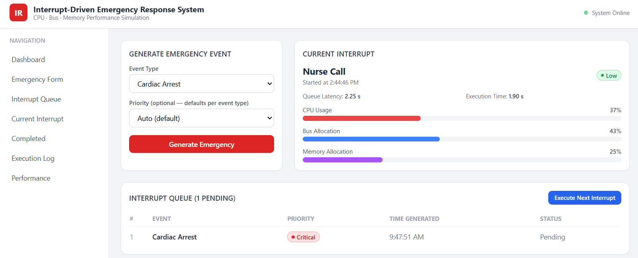
Fig no:3.3

3.2 Constraints & Applicable Standards
Standard / Code | Requirement | How Applied in This Project
IEEE 1016 | Software design description principles | Reference for documenting system design and architecture
IEEE 29148 | Requirements engineering guidance | Reference for organizing functional and non-functional requirements
IEEE referencing conventions | Consistent technical citation | Used for technical references
Technical constraints include simulation-based implementation, no real hospital hardware connection, no real patient data, modeled rather than physical bus and memory measurements, implementation-dependent performance, and exclusion of clinical decision-making.

3.3 Design Specifications
Parameter | Target / Requirement | Unit | Priority
Emergency event generation | Multiple emergency types | Events | High
Interrupt priority | Critical events receive higher priority | Priority level | High
Interrupt queue | Store pending events | Events | High
CPU processing | One interrupt at a time | Interrupt | High
Bus simulation | Record bus activity | Usage | Medium
Memory simulation | Allocate/release memory | Usage | Medium
CPU analysis | Display CPU usage | % | High
Bus analysis | Display bus usage | % | High
Memory analysis | Display memory usage | % / MB | High
Performance visualization | Generate charts | Charts | Medium
Execution log | Record processing activity | Log | Medium

3.4 Alternative Solutions & Evaluation
Alternative 1: Simple Sequential Emergency Processing. This approach processes emergency events sequentially according to arrival order. It is simple but does not adequately represent interrupt priority.
Alternative 2: Interrupt-Driven Priority Processing. Each emergency event is represented as an interrupt and assigned a priority. The CPU processes pending interrupts according to priority while recording resource usage.
Alternative 3: AI-Based Emergency Prioritization. An AI model determines priority dynamically. This could provide intelligent prioritization but requires datasets, model development and additional computational resources.
Criterion | Weight | Alternative 1 | Alternative 2 | Alternative 3
Performance | 30% | 3 | 5 | 4
Cost | 20% | 5 | 5 | 2
Safety | 20% | 3 | 4 | 4
Sustainability | 10% | 5 | 5 | 3
Reliability | 20% | 3 | 5 | 3
Weighted suitability | 100% | 3.7 | 4.8 | 3.2
Scale: 1 = Poor, 5 = Excellent.

3.5 Selected Design & Detailed Design
The selected design is an interrupt-driven priority-based emergency response system integrated with CPU, bus and memory performance analysis.
Architecture: Emergency Event Generator → Interrupt Controller / Priority Assignment → Interrupt Queue → CPU Interrupt Processing → Bus & Memory Simulation → Performance Analysis → Dashboard / Report.
The system generates emergency events and converts them into interrupt requests. Each event receives a priority level. Pending events are maintained in the interrupt queue. The CPU processes the interrupts according to priority. During processing, the system simulates bus access and memory allocation/release. The resulting CPU, bus and memory activity is analyzed and displayed.
Suggested emergency priority model: Heart Attack – 1 (Critical); Fire Alarm – 1 (Critical); Low Oxygen Level – 2 (High); Nurse Emergency Call – 3 (Medium). If the implementation uses different priority values, the actual values should be inserted.
Key calculations:
CPU Usage (%) = (CPU Busy Time / Total Observation Time) × 100
Memory Usage (%) = (Memory Used / Total Available Memory) × 100
Bus Usage (%) = (Bus Active Time / Total Observation Time) × 100
Interrupt Latency = Interrupt Service Start Time − Interrupt Detection Time

3.6 Trade-off Analysis
Design Decision | Alternative Considered | Benefit | Disadvantage | Final Decision & Justification
Priority-based processing | First-come-first-served | Critical events can be processed earlier | Requires priority management | Priority-based processing selected
Interrupt queue | Immediate sequential processing | Handles multiple pending events systematically | Requires queue management | Interrupt queue selected
Simulation | Physical hardware | Lower cost and easier experimentation | Does not represent all real hardware effects | Simulation selected
Modular architecture | Single integrated module | Easier maintenance and testing | Requires module interfaces | Modular architecture selected
Performance charts | Text-only output | Easier performance interpretation | Requires additional visualization | Charts selected

3.7 Sustainability, Ethics, Safety, Risk & Security
Domain | Consideration | Evidence Evaluated | Impact on Final Decision
Sustainability | Avoid unnecessary physical hardware during initial development | Simulation-based implementation | Reduced hardware requirement and development cost
Ethics | Avoid presenting simulated results as real clinical performance | Project scope and simulation approach | System positioned as educational prototype
Health & Safety | System must not be treated as a medical decision-making system | No real patient control or diagnosis | Clinical deployment excluded from current scope
Security | Emergency information should be protected in a future real deployment | Future IoT/cloud integration requirements | Security considered for future implementation
Ethical considerations: The project is a computer architecture simulation and should not be interpreted as a clinically validated emergency response platform. Future integration with real hospital devices would require appropriate validation, data protection, safety controls and institutional approval.
Safety considerations: Incorrect prioritization or processing delays could have serious consequences in a real emergency system. The current project does not directly control medical equipment or make medical decisions.
Security considerations: A real deployment involving emergency records, hospital IoT devices or cloud storage would require authentication, authorization, secure communication, access control and protection of sensitive information.

Risk Register
Risk | Likelihood | Severity | Risk Level | Mitigation | Residual Risk
Incorrect interrupt priority | Medium | High | High | Define and test priority rules | Medium
Interrupt queue processing error | Medium | High | High | Perform queue-based test cases | Low–Medium
Incorrect CPU usage calculation | Medium | Medium | Medium | Verify calculation using known test cases | Low
Incorrect memory tracking | Medium | Medium | Medium | Test allocation and release operations | Low
Bus usage calculation error | Medium | Medium | Medium | Validate bus activity calculations | Low
Software execution failure | Low | Medium | Low | Debug and perform repeated testing | Low
Incorrect performance interpretation | Medium | Medium | Medium | Compare results across multiple test cases | Low
Future IoT security vulnerabilities | Medium | High | High | Apply authentication and secure communication in future versions | Medium

CHAPTER 4

IMPLEMENTATION, TESTING & RESULTS, PROJECT MANAGEMENT

4.1 Development Approach & Resources
The project was developed using a modular approach. The first stage defined the emergency-event model and how each event could be represented as an interrupt. The second stage implemented interrupt generation, priority assignment, queue management and CPU processing. The third stage implemented bus-access and memory-usage simulation. Finally, performance information was collected and presented through suitable outputs and charts.
Resource | Purpose
Computer system | Development and execution
Programming environment | System implementation
CPU simulation logic | Interrupt processing
Interrupt queue | Pending event management
Performance-analysis module | CPU, bus and memory analysis
Visualization/dashboard | Performance presentation
Documentation tools | Report preparation

4.2 Hardware / Software / Fabrication Implementation & Modern Tools Used

Software Implementation
Module 1 – Emergency Interrupt Management: creates emergency events, assigns priority levels, stores events in the interrupt queue, selects the appropriate interrupt for CPU processing, processes the interrupt, records completed events and maintains the execution log.
Module 2 – Bus and Memory Performance Analysis: performs bus-access simulation, memory allocation, memory release, CPU usage calculation, performance-chart generation and performance-report generation.
Tool / Software / Equipment | Purpose | Stage Used
Programming environment | Software development | Implementation
Computer system | Execution and testing | All stages
Simulation logic | CPU, bus and memory modeling | Implementation
Visualization/dashboard | Performance display | Analysis
Documentation tools | Report preparation | Documentation
Replace 'Programming environment' with the actual software name used in the implementation, if applicable.

4.3 Test Plan & Verification
Requirement | Test Method | Acceptance Criterion
Emergency event generation | Generate each defined emergency event | Event appears correctly
Priority assignment | Generate events with different priorities | Correct priority is assigned
Interrupt queue | Generate multiple events | Events are stored in queue
Priority processing | Generate simultaneous events | Higher-priority event is selected appropriately
CPU processing | Process queued interrupts | Interrupt completes successfully
Execution logging | Process multiple events | Processing activity appears in log
Bus simulation | Execute event processing | Bus activity is recorded
Memory allocation | Start emergency processing | Required memory is allocated
Memory release | Complete event processing | Allocated memory is released
CPU analysis | Run workload | CPU usage is displayed
Bus analysis | Run workload | Bus usage is displayed
Memory analysis | Run workload | Memory usage is displayed
Performance report | Complete simulation | Performance report is generated

Specification Verification
Specification | Required Value | Achieved Value | Status
Emergency event generation | Multiple events | [Insert actual value] | [Pass/Fail]
Priority assignment | Priority for every event | [Insert actual result] | [Pass/Fail]
Interrupt queue | Pending events stored | [Insert actual result] | [Pass/Fail]
CPU processing | Interrupts processed | [Insert actual result] | [Pass/Fail]
Bus analysis | Bus usage displayed | [Insert actual result] | [Pass/Fail]
Memory analysis | Memory usage displayed | [Insert actual result] | [Pass/Fail]
CPU analysis | CPU usage displayed | [Insert actual result] | [Pass/Fail]
Performance charts | Charts generated | [Insert actual result] | [Pass/Fail]
Performance report | Report generated | [Insert actual result] | [Pass/Fail]

4.4 Results
The implemented system generates emergency events and represents them as interrupt requests. The events are assigned priorities and stored in the interrupt queue before being processed by the CPU. During execution, the system records interrupt-processing activity and generates CPU, bus and memory performance information.
Expected output sequence: Emergency Event Generation → Priority Assignment → Interrupt Queue → CPU Interrupt Processing → Bus/Memory Activity → Performance Analysis → Performance Report.
Performance Results — enter measurements from the actual implementation. Do not fabricate numerical values.
Test Case | Number of Events | CPU Usage (%) | Bus Usage (%) | Memory Usage (%) | Interrupt Processing Result
Test Case 1 | 5 | 58% | 59.25% | 36% | 98%
Test Case 2
Test Case 3
Test Case 4
Test Case 5
Insert actual project screenshots/graphs for emergency interrupt management, bus and memory analysis, CPU usage, bus usage, memory usage and final performance report.
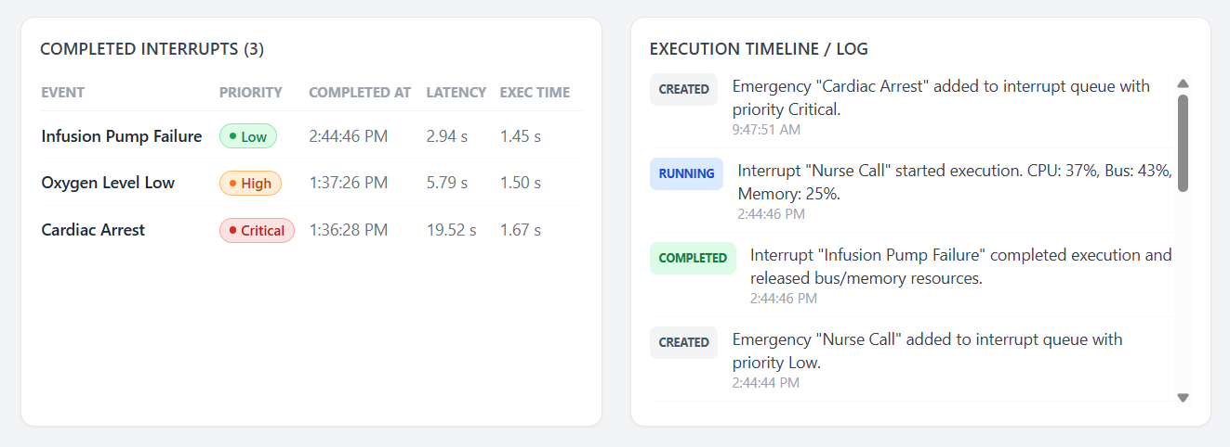
Fig no:4.4

4.5 Data Analysis & Engineering Judgment
The performance analysis focuses on three primary system resources: CPU, bus and memory. CPU utilization indicates the processing load associated with handling emergency interrupts. As the number of emergency events increases, the CPU may experience increased activity because more interrupt-processing operations must be performed.
Bus usage represents the simulated communication activity associated with the processing of emergency events. Increased event-processing activity may produce additional bus operations depending on the implementation.
Memory usage represents the memory resources associated with storing and processing emergency events. Memory allocation increases when events require storage, while memory release after event completion helps prevent unnecessary resource occupation.
The actual measured values should be analyzed using the following observations: CPU Usage – [Describe increase/decrease from your graph]; Bus Usage – [Describe increase/decrease from your graph]; Memory Usage – [Describe increase/decrease from your graph]; Interrupt Processing – [Describe priority-processing behavior]; Maximum observed utilization – [Insert value]; Minimum observed utilization – [Insert value].

4.6 Comparison with Existing Solutions & Achievement of Objectives
Objective | Evidence | Achievement (Fully/Partially/Not Achieved)
Generate emergency events | Emergency event-generation module | Fully Achieved
Process events using CPU interrupts | Interrupt-processing module | Fully Achieved
Give higher priority to critical emergencies | Priority assignment and queue | Fully Achieved
Simulate CPU processing | CPU processing logic | Fully Achieved
Analyze bus usage | Bus-performance module | Fully Achieved
Analyze memory usage | Memory-performance module | Fully Achieved
Display system performance | Dashboard/charts/report | Fully Achieved

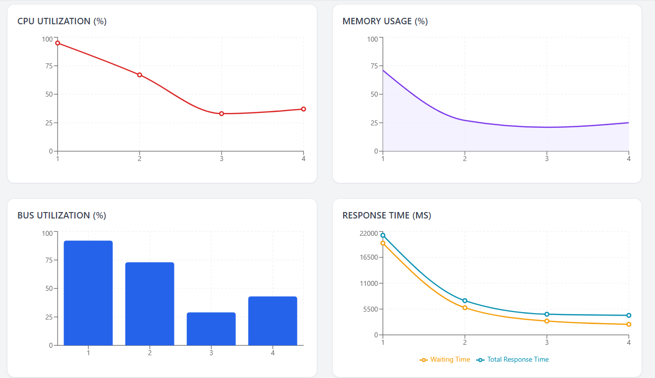
Fig no:4.5

4.7 Strengths & Limitations
Strengths:
• Uses interrupt-driven processing to represent emergency events.
• Supports priority-based emergency processing.
• Maintains an interrupt queue.
• Demonstrates CPU interrupt processing.
• Integrates bus and memory performance analysis.
• Provides CPU, bus and memory performance outputs.
• Uses a modular architecture.
• Provides an educational demonstration of computer architecture concepts.
• Can be extended toward IoT and AI-based systems.
Limitations:
• The current implementation is simulation-based.
• It does not directly connect to real hospital devices.
• It does not process real patient data.
• It does not perform medical diagnosis.
• Bus and memory measurements represent the simulation rather than complete physical hardware behavior.
• Real-world interrupt latency may differ from simulated values.
• The system has not been clinically validated.
• AI-based automatic prioritization is not currently implemented.
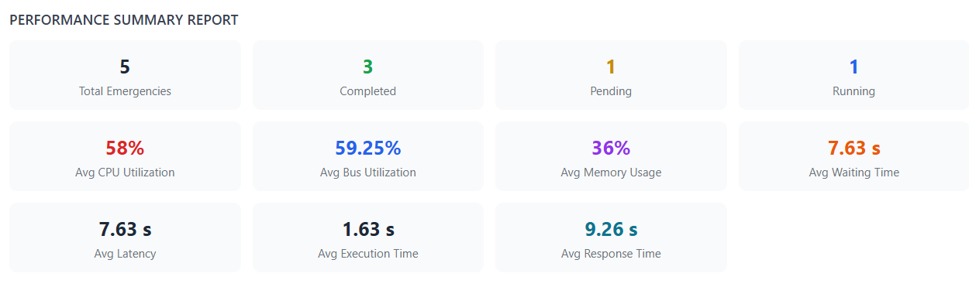
Fig no :4.6

4.8 Project Planning, Roles & Budget
Phase | Activity | Duration
Phase 1 | Problem identification and topic selection | Week 1
Phase 2 | Literature review | Week 2
Phase 3 | System requirements and architecture design | Week 3
Phase 4 | Emergency interrupt module development | Week 4
Phase 5 | Bus and memory analysis module development | Week 5
Phase 6 | Module integration | Week 6
Phase 7 | Testing and debugging | Week 7
Phase 8 | Performance analysis | Week 8
Phase 9 | Documentation and report preparation | Week 9
Phase 10 | Final presentation and demonstration | Week 10
Student | Assigned Responsibility | Actual Contribution
N. Nesarajan | Emergency interrupt management and system integration | Emergency-event generation, priority handling, interrupt queue and CPU-processing implementation
J. Yukesh Kumar | Bus and memory performance analysis | Bus simulation, memory management, performance calculations and visualization
Item | Estimated Cost | Actual Cost
Computer / existing system | ₹0 | ₹0
Software / development tools | ₹0* | ₹0*
Documentation | ₹200 | [Insert]
Internet / research resources | ₹300 | [Insert]
Miscellaneous | ₹200 | [Insert]
Total | ₹700 | [Insert actual total]
*Only use ₹0 if freely available/existing tools were actually used.

CHAPTER 5

CONCLUSION, FUTURE WORK AND REFLECTION

5.1 Conclusion
The project “Interrupt-Driven Emergency Response Management System with Bus and Memory Performance Analysis” demonstrates the application of important computer architecture concepts to an emergency-response scenario.
The system represents emergency events such as heart attacks, fire alarms, low oxygen levels and nurse emergency calls as interrupt requests. These events are assigned priorities and stored in an interrupt queue before being processed by the CPU. This approach demonstrates how interrupt-driven processing can be used to organize and prioritize time-sensitive events.
The project also incorporates bus and memory performance analysis. Bus access is simulated, memory allocation and release are represented, and CPU, bus and memory usage are analyzed. The resulting performance information can be displayed through charts and reports.
The developed system provides an understandable connection between an emergency-response application and fundamental computer architecture concepts including interrupt handling, CPU processing, bus communication and memory management. The project therefore achieves its main educational engineering objective of demonstrating interrupt-driven emergency processing together with system-resource performance analysis.

5.2 Future Work
• Real Hospital IoT Integration – Real sensors and hospital IoT devices could be connected to generate emergency events automatically.
• AI-Based Emergency Prioritization – AI techniques could dynamically classify emergency severity and determine interrupt priority.
• Multi-Hospital Monitoring – The system could monitor emergency events across multiple hospitals.
• Mobile Application – A mobile application could provide emergency notifications to authorized doctors and nurses.
• Cloud-Based Emergency Records – Emergency-event records could be securely stored in cloud infrastructure.
• Real Hardware Performance Analysis – CPU, bus and memory behavior could be evaluated on an actual processor or embedded platform.
• Automated Performance Reporting – The system could automatically generate detailed performance reports after every simulation.
• Expansion to Other Domains – The architecture could be adapted to industrial systems, airports, smart cities and other environments.

5.3 Professional Learning & Individual Reflection

New Knowledge Acquired
• Understanding of interrupt-driven CPU processing.
• Understanding of interrupt priority and queue management.
• Understanding of CPU resource utilization.
• Understanding of bus activity and communication.
• Understanding of memory allocation and release.
• Understanding of system-level performance analysis.
• Understanding of emergency-response system architecture.

Engineering & Professional Skills Developed
• System architecture design.
• Modular software development.
• Requirements analysis.
• Testing and debugging.
• Performance analysis.
• Technical documentation.
• Team collaboration.
• Engineering decision-making.
• Technical presentation.

Individual Reflection – N. Nesarajan
Working on this project helped me understand how interrupt-driven processing can be applied to a practical emergency-response scenario. One of the challenging aspects was designing the emergency-event flow so that multiple events could be represented and processed according to their priority. I learned how interrupt queues and priority handling can influence CPU processing. I also gained experience in system-level thinking by considering the relationship between interrupt processing and CPU, bus and memory resources. If I were to redesign the project, I would improve the real-time performance measurement and integrate actual hardware or IoT devices for more realistic evaluation.

Individual Reflection – J. Yukesh Kumar
This project helped me develop a better understanding of bus communication, memory management and performance analysis in computer architecture. The main challenge was representing resource usage in a way that could be measured and displayed clearly. Working on the bus and memory analysis module helped me understand how system resources are affected during event processing. I also gained experience in analyzing performance information and presenting it through charts. If the project were repeated, I would extend the performance analysis to real hardware and include more detailed measurements such as interrupt latency and memory-access performance.

REFERENCES
[1] R. Ghoni and T. Ibrahim, “Integration of Emergency Response Management System with Internet of Things,” Journal of Physics: Conference Series, vol. 1874, p. 012074, 2021, doi: 10.1088/1742-6596/1874/1/012074.
[2] L. Yang, S. H. Yang, and L. Plotnick, “How the Internet of Things Technology Enhances Emergency Response Operations,” Technological Forecasting and Social Change, vol. 80, no. 9, pp. 1854–1867, 2013, doi: 10.1016/j.techfore.2012.07.011.
[3] N. Pushpalatha et al., “Intelligent IoT and AI-Driven Ambulance Dispatch and Traffic Preemption System,” in Proc. ICCETM, 2025, doi: 10.1109/ICCETM66557.2025.11557822.
[4] V. Devi et al., “A Real-Time Adaptive AI Based Traffic Management Framework for Ambulance Priority,” in Proc. ICPCSN, 2026, doi: 10.1109/ICPCSN68523.2026.11543612.
[5] A. S. Prasad et al., “IoT-Based Emergency Vehicle Priority Traffic Control Using Realtime Signal Adjustment,” in Proc. IEEE GSEACT, 2026, doi: 10.1109/GSEACT68539.2026.11619940.
[6] J. Bruno et al., “Interrupt Latency,” Proceedings of the Workshop on Embedded Systems, USENIX.
[7] Microchip, “Interrupt Performance and Interrupt Latency,” 2026.
[8] Microchip, “Interrupt Latency — CPU/Bus/Memory Performance.”
[9] A. N. Sloss, D. Symes, and C. Wright, ARM System Developer’s Guide: Designing and Optimizing System Software.
[10] C. Walls, “Measuring Interrupt Latency,” Siemens Embedded Software, 2012.
Note: Bibliographic details should be verified against the original publications before final submission; these entries preserve the references supplied in the project PPT.

APPENDICES

Appendix A – Detailed Calculations
CPU Usage (%) = (CPU Busy Time / Total Observation Time) × 100
Memory Usage (%) = (Memory Used / Total Available Memory) × 100
Bus Usage (%) = (Bus Active Time / Total Observation Time) × 100
Interrupt Latency = Interrupt Service Start Time − Interrupt Detection Time
Insert actual measured values and calculations from the implementation.

Appendix B – Engineering Drawings / Schematics
Proposed System Architecture:
Emergency Event Generator → Priority Assignment → Interrupt Queue → CPU Interrupt Processing → Bus / Memory Analysis → Performance Analysis → Dashboard / Report

Appendix C – Source Code / Code Repository Information
Include the main program, emergency event generation, interrupt priority, interrupt queue, CPU processing, bus simulation, memory management, performance analysis and visualization modules. Include only essential code excerpts in the report and maintain complete source code separately if required.

Appendix D – Datasheets
Not applicable to the current simulation-based implementation unless physical hardware is used.

Appendix E – Experimental / Raw Data
Test Case | Events | CPU Usage (%) | Bus Usage (%) | Memory Usage (%) | Interrupt Latency
1 | [ ] | [ ] | [ ] | [ ] | [ ]
2 | [ ] | [ ] | [ ] | [ ] | [ ]
3 | [ ] | [ ] | [ ] | [ ] | [ ]
4 | [ ] | [ ] | [ ] | [ ] | [ ]
5 | [ ] | [ ] | [ ] | [ ] | [ ]

Appendix F – Ethics / Institutional Approval
No patient data, clinical intervention or direct medical-device control is involved in the current simulation-only project. Any future deployment involving real patients, hospital equipment or patient data would require appropriate institutional and ethical approvals.

Appendix G – Project Meeting / Progress Records
Date | Meeting / Activity | Work Completed | Next Action
[Date] | Topic discussion | Project topic finalized | Define requirements
[Date] | Requirement analysis | System requirements identified | Design architecture
[Date] | Design review | Interrupt architecture designed | Implement Module 1
[Date] | Development review | Interrupt module developed | Implement Module 2
[Date] | Integration review | Modules integrated | Perform testing
[Date] | Testing review | Test cases executed | Analyze performance
[Date] | Final review | Report and presentation prepared | Final submission

Appendix H – User / Industry Feedback
Not applicable unless feedback was collected. Add guide/faculty/user feedback here if available.

Appendix I – Publications / Patents / Competitions / Product Outcomes
Not applicable unless the project has been submitted to a competition, publication, patent process or product-development activity.

Appendix J – Individual Contribution Evidence
Include evidence such as version-control contribution, module screenshots, development records, testing records, meeting records, presentation contribution and report-section contribution.

CAPSTONE PROJECT OUTCOME MAPPING SHEET
Outcome Evidence | SO / Area | Location in This Report
Complex engineering problem formulation | SO1 | Ch. 1, Ch. 2
Engineering design under constraints | SO2 | Ch. 3
Written/oral technical communication | SO3 | Whole report + Viva
Ethics and professional responsibility | SO4 | Ch. 3 (3.7)
Teamwork and leadership | SO5 | Ch. 4 (4.8)
Experimentation, analysis, engineering judgment | SO6 | Ch. 4 (4.3–4.6)
Independent acquisition of new knowledge | SO7 | Ch. 5 (5.3)
Standards | SO2 | Ch. 3 (3.2)
Sustainability and societal/environmental impact | SO2/SO4 | Ch. 3 (3.7)
Risk assessment and mitigation | SO2/SO4 | Ch. 3 (3.7)
Security considerations | Relevant SO | Ch. 3 (3.7)
Integrated/system-level engineering | SO1/SO2 | Ch. 3 (3.5)
Project planning and management | SO5 | Ch. 4 (4.8)
Individual contribution | SO1–SO7 | Contribution Statement + Ch. 4 (4.8)

